**NAME: CHUKKA BHAVANA** **ID NUM:220031128**

Creating Tables:

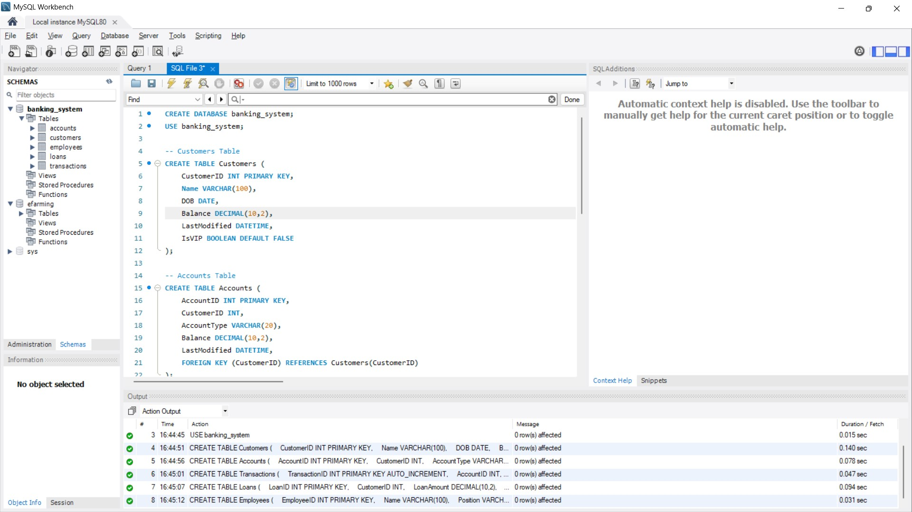

Inserting the Data:

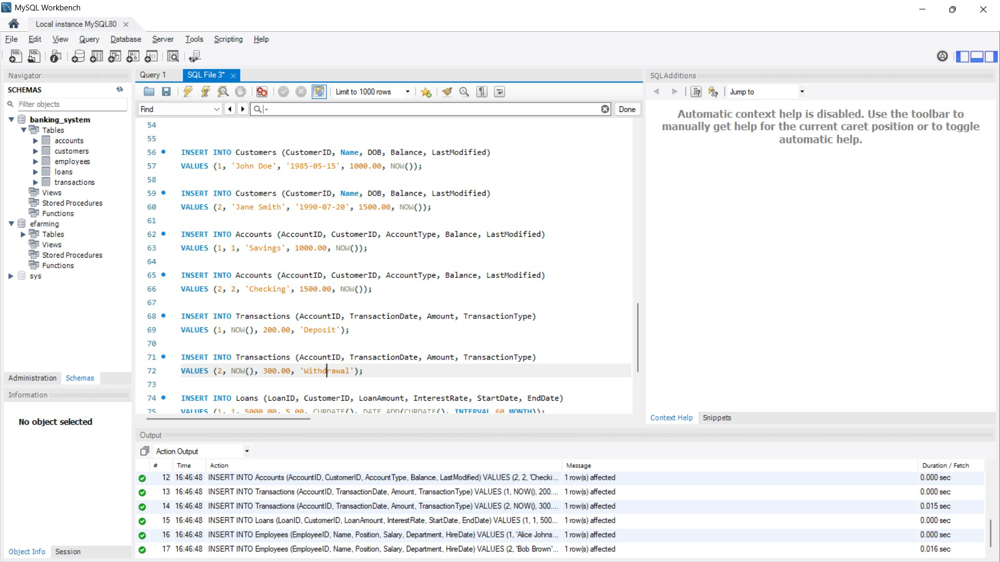

# Exercise 1: Control Structures

**Scenario 1:** The bank wants to apply a discount to loan interest rates for customers above 60 years old.

**Question:** Write a PL/SQL block that loops through all customers, checks their age, and if they are above 60, apply a 1% discount to their current loan interest rates. **ANS**

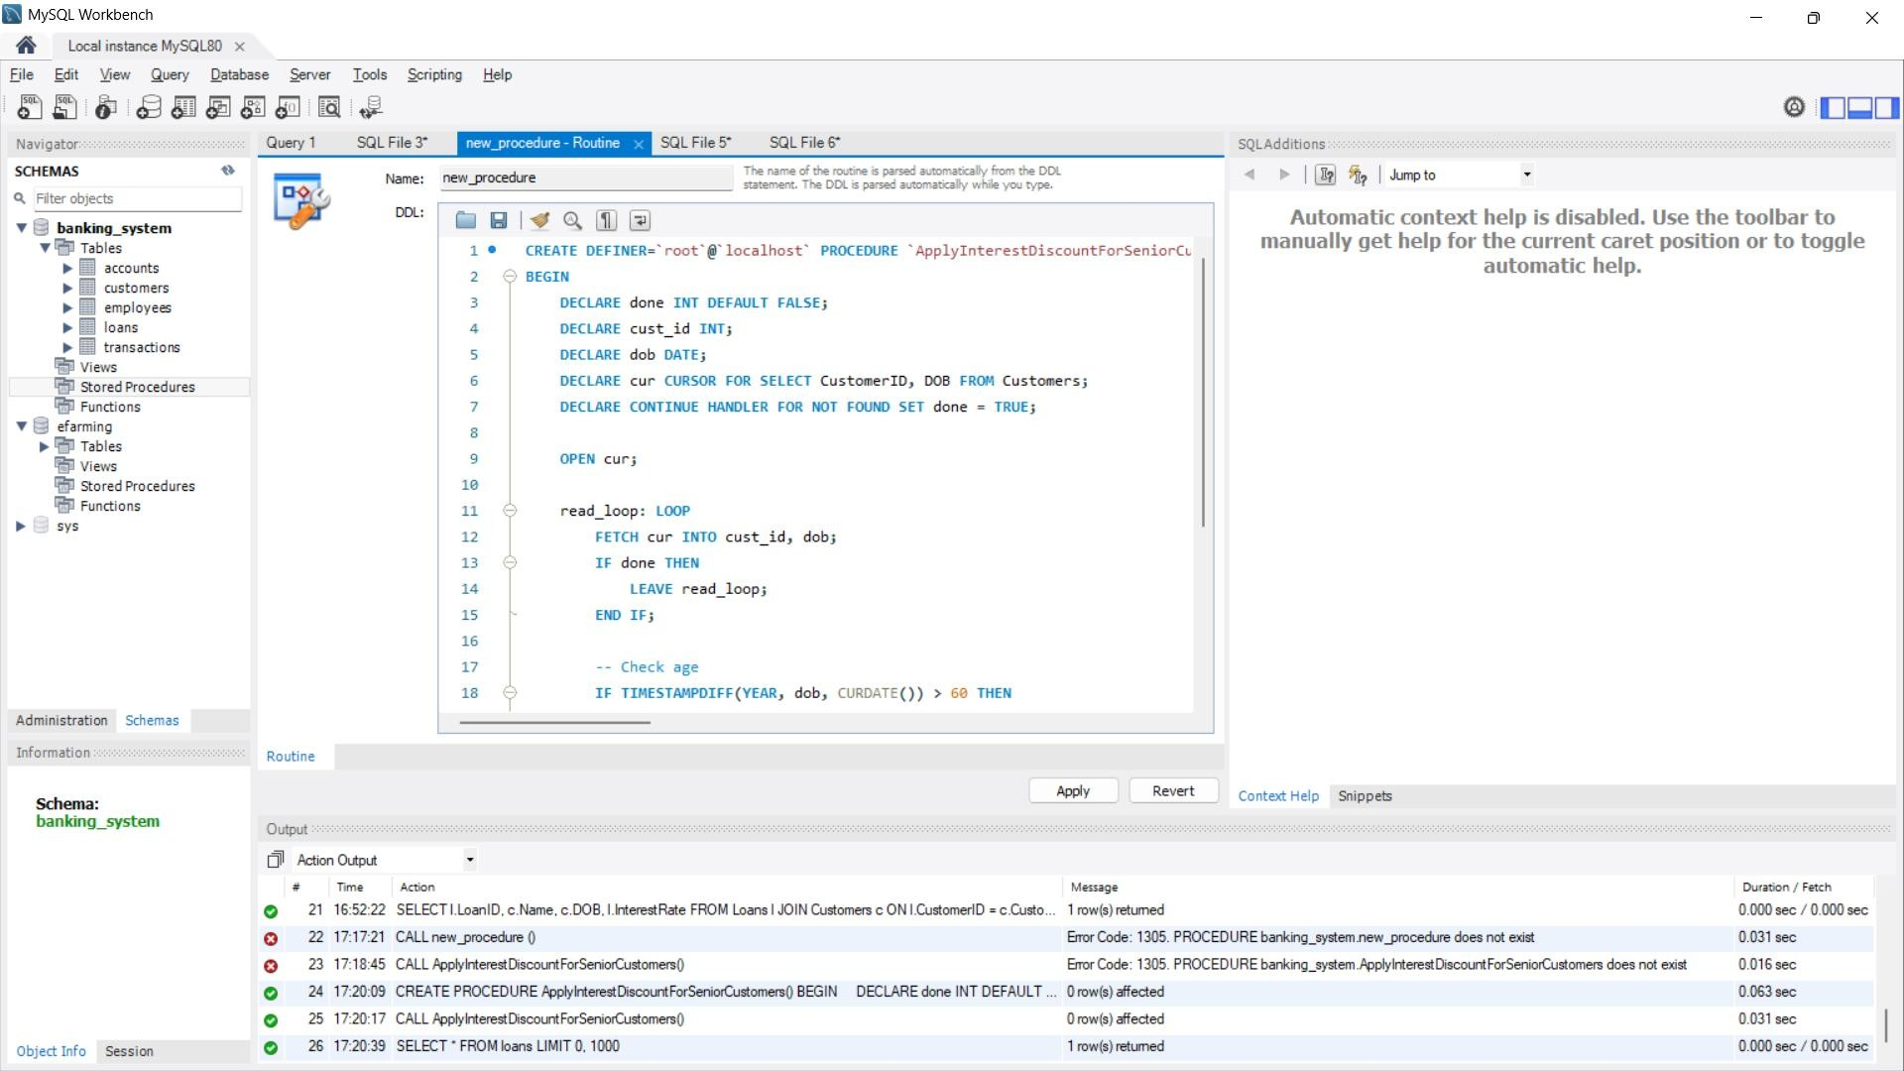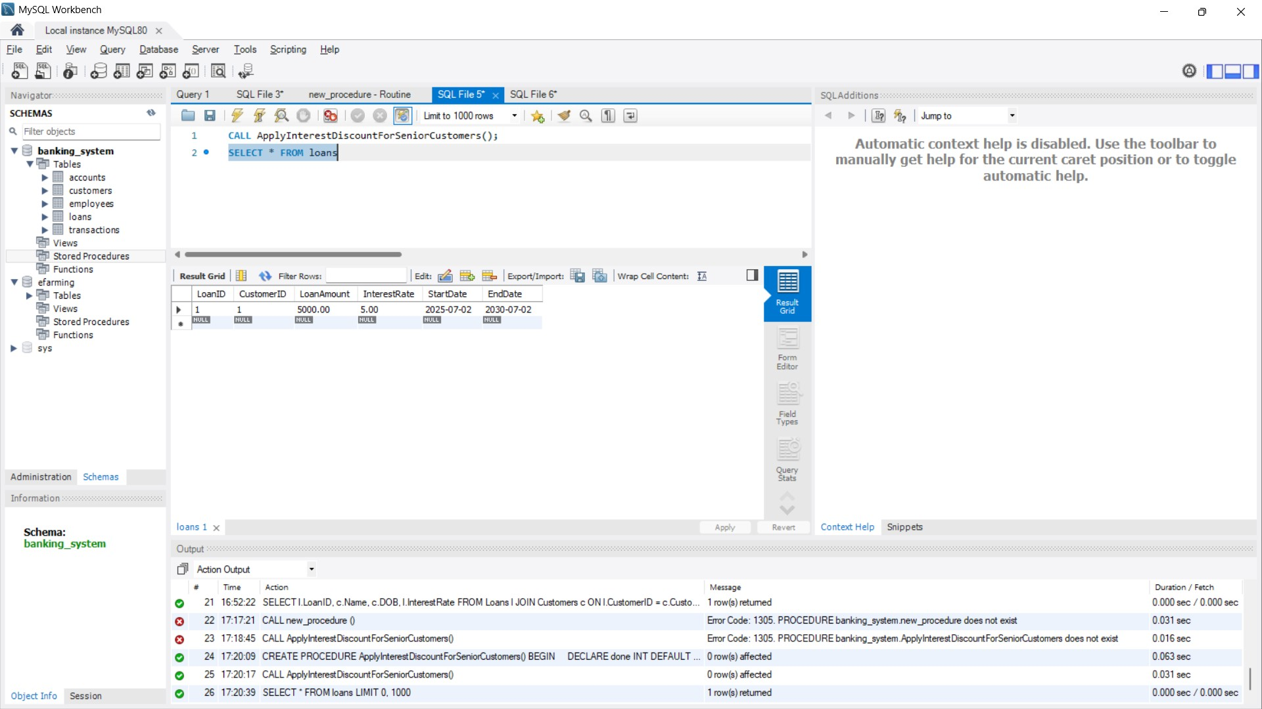

**Scenario 2:** A customer can be promoted to VIP status based on their balance.

**Question:** Write a PL/SQL block that iterates through all customers and sets a flag IsVIP to TRUE for those with a balance over $10,000. **ANS**

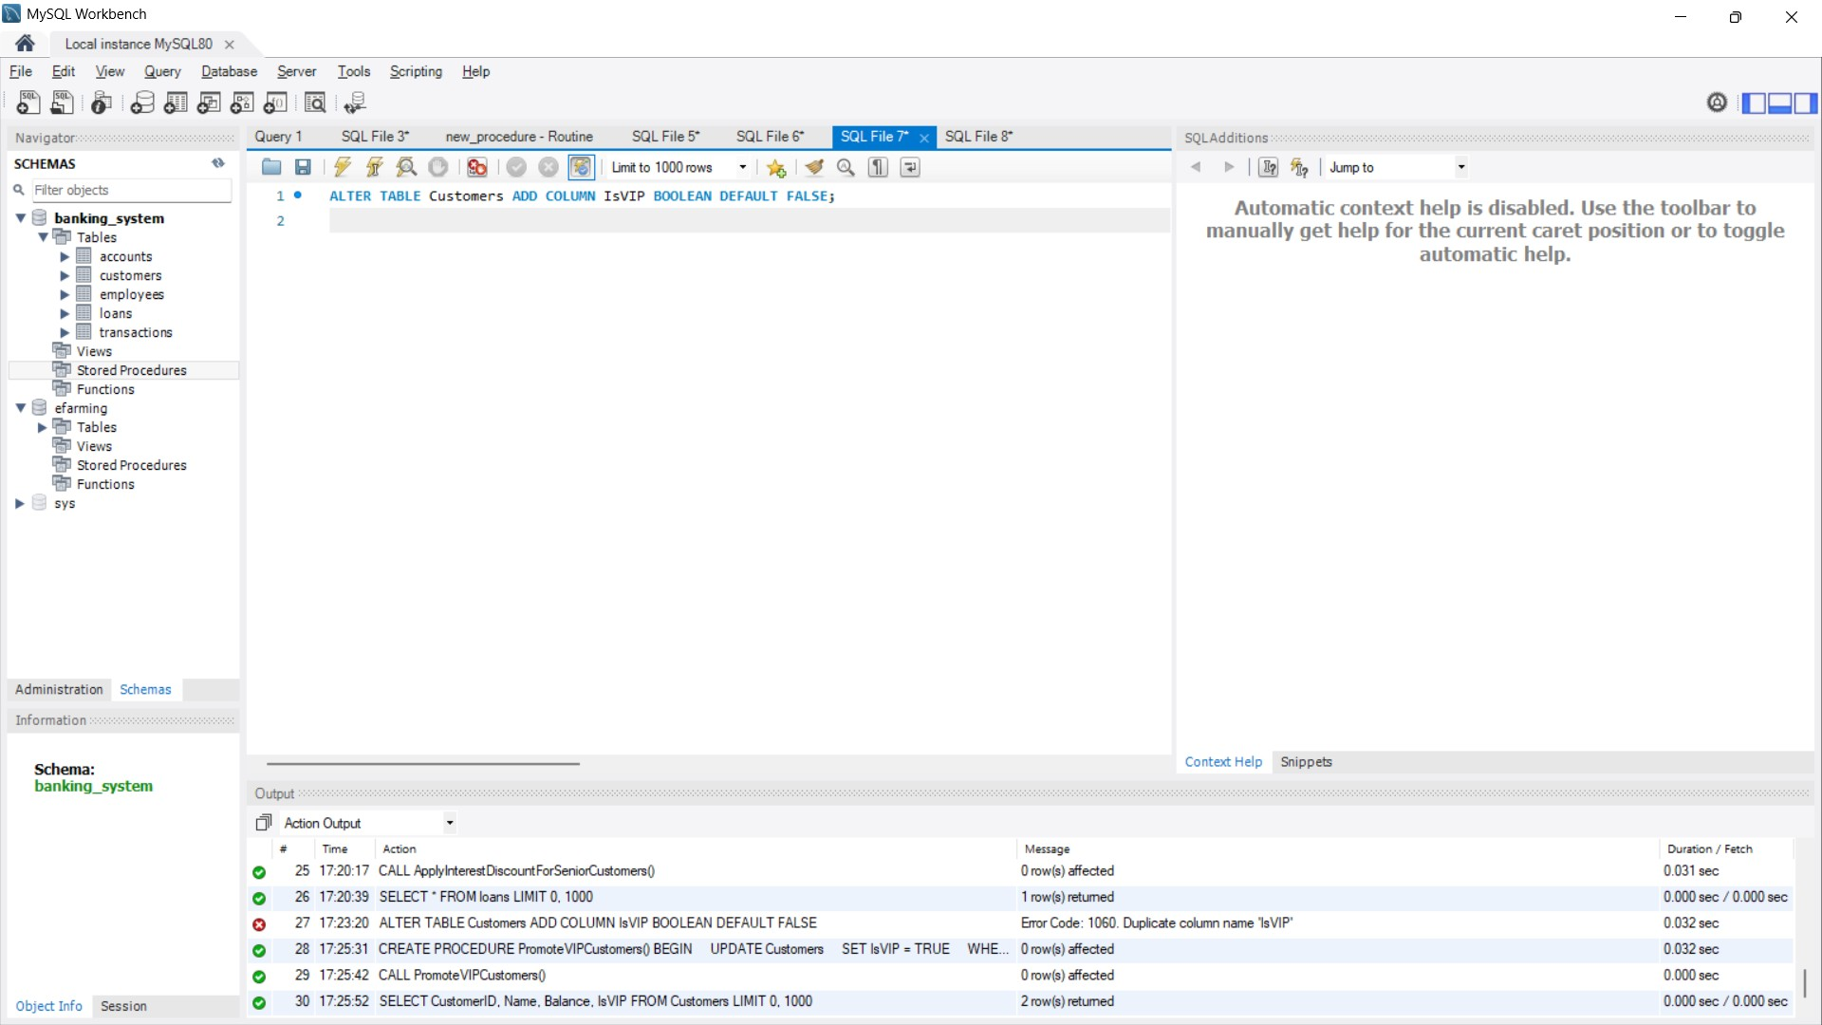

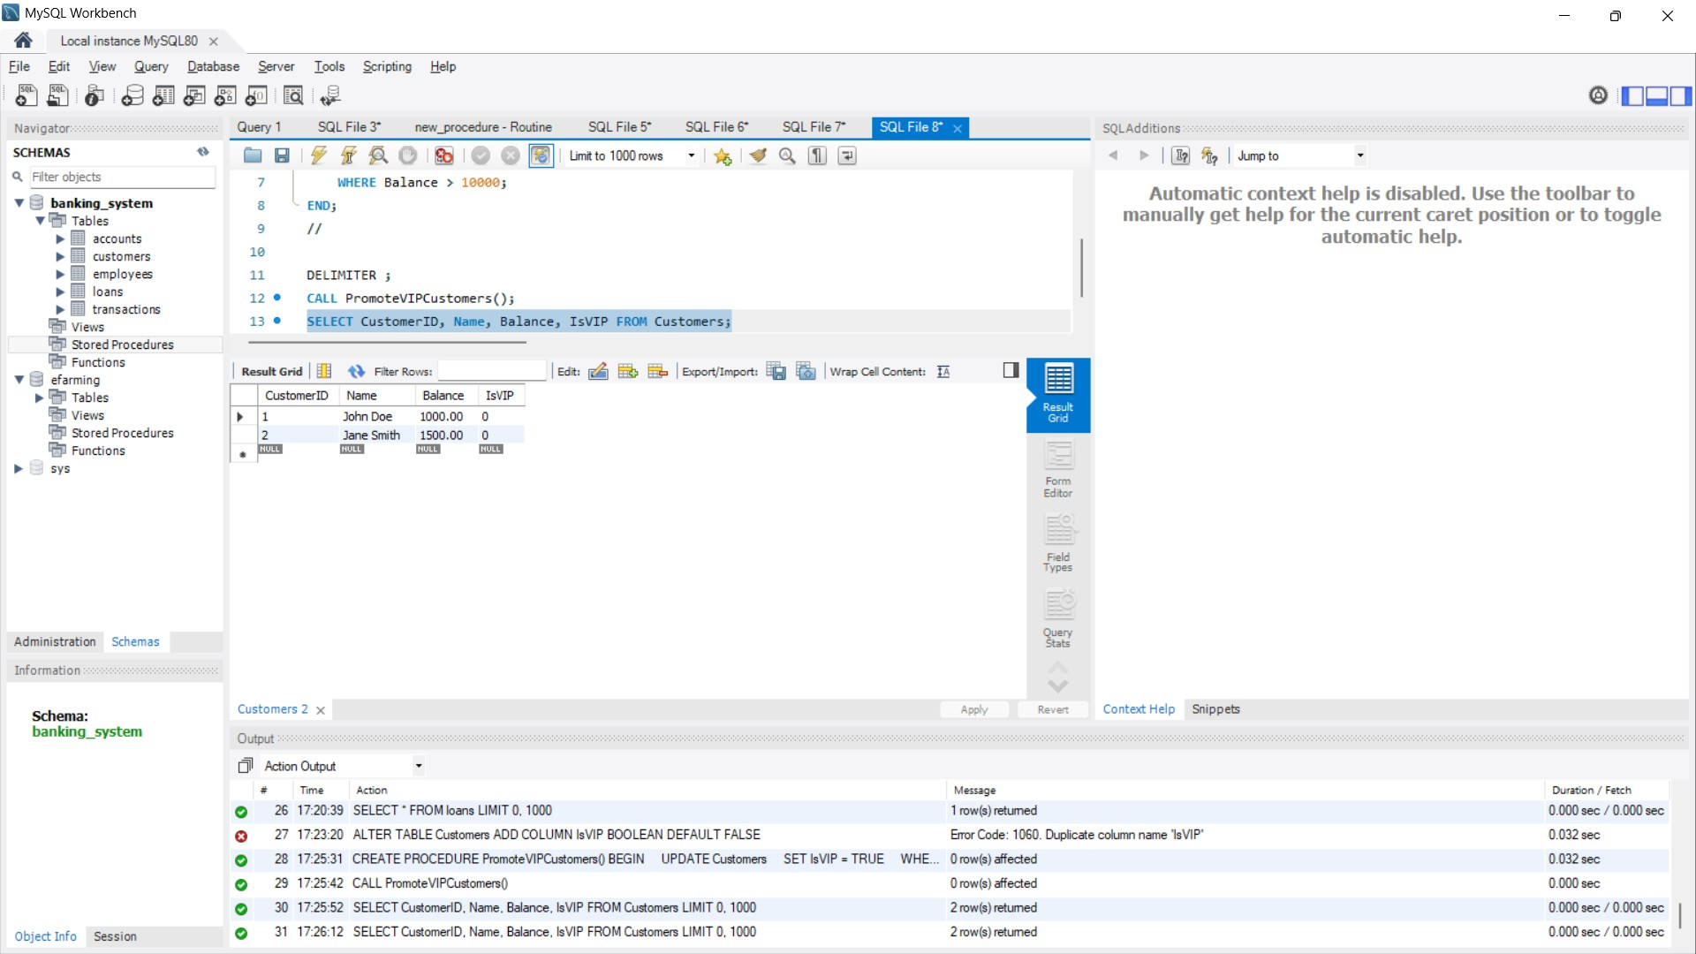

**Scenario 3:** The bank wants to send reminders to customers whose loans are due within the next 30 days.

**Question:** Write a PL/SQL block that fetches all loans due in the next 30 days and prints a reminder message for each customer. **ANS**

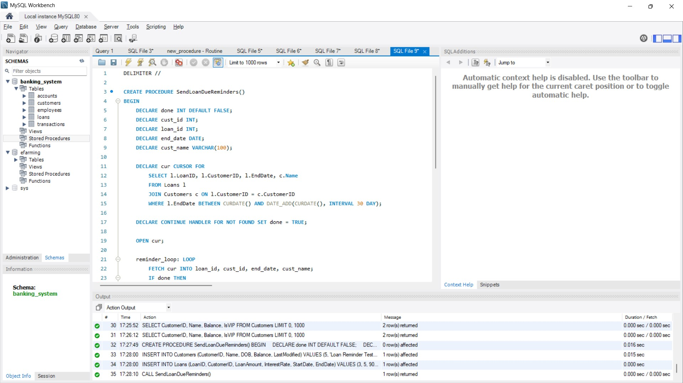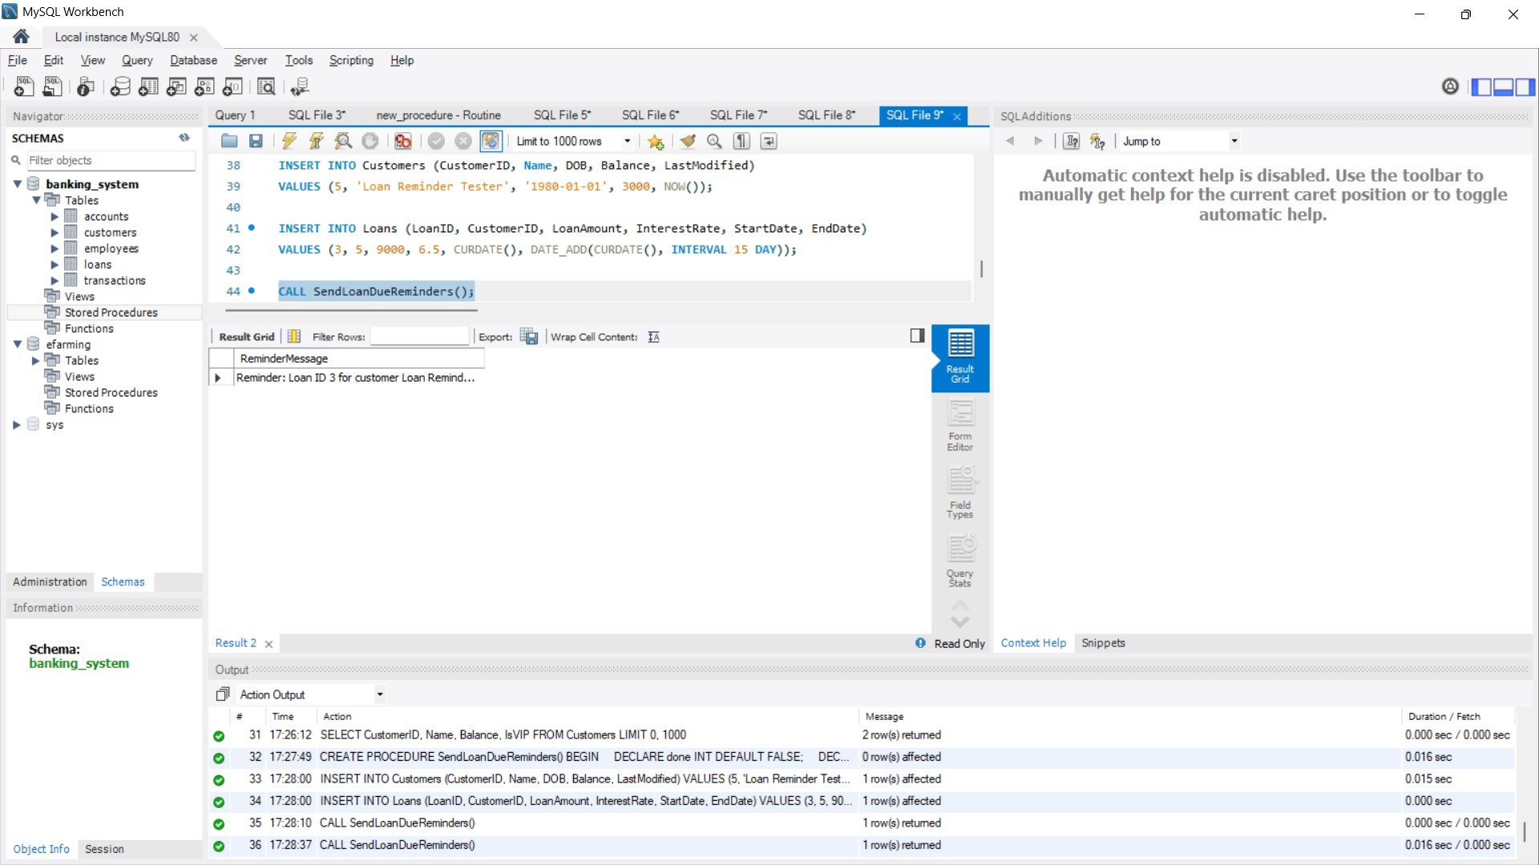

# Exercise 3: Stored Procedures

**Scenario 1:** The bank needs to process monthly interest for all savings accounts.

**Question:** Write a stored procedure **ProcessMonthlyInterest** that calculates and updates the balance of all savings accounts by applying an interest rate of 1% to the current balance. **ANS**

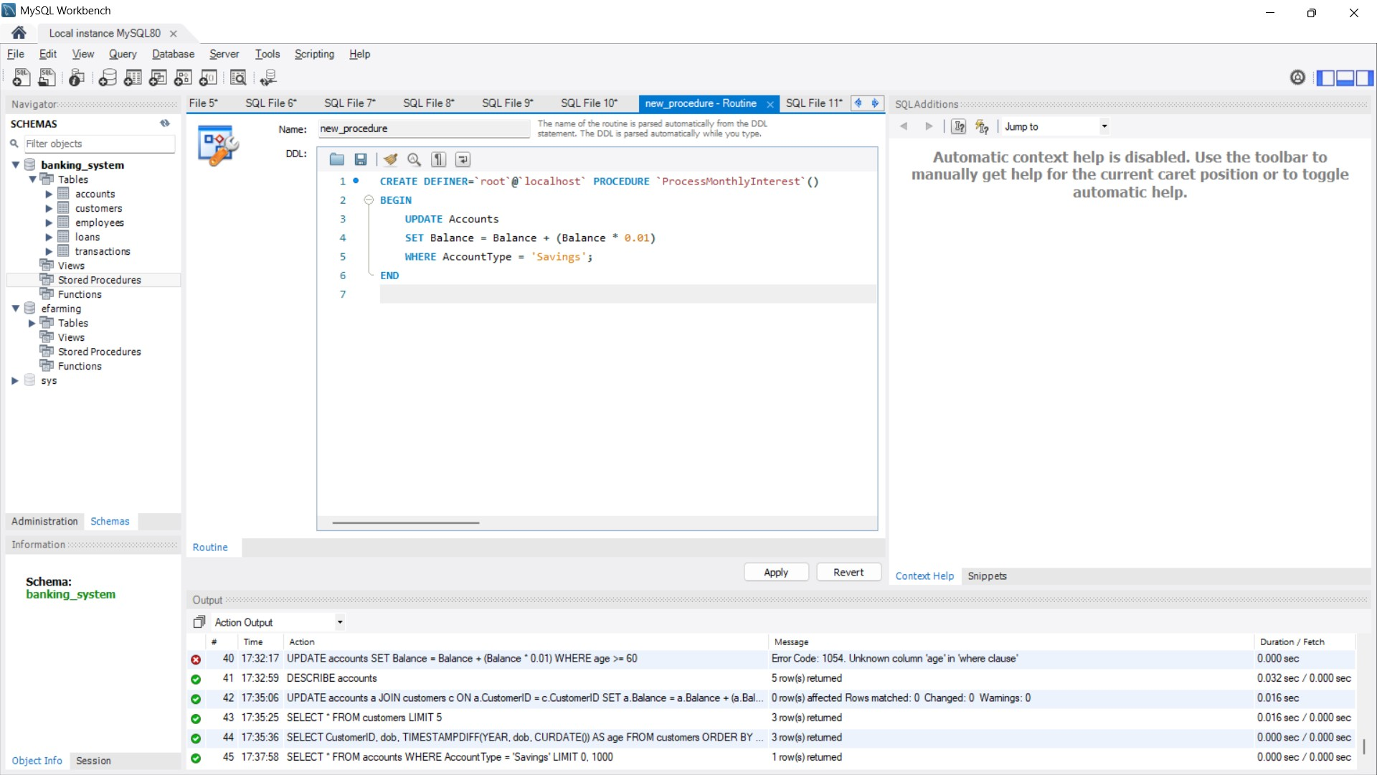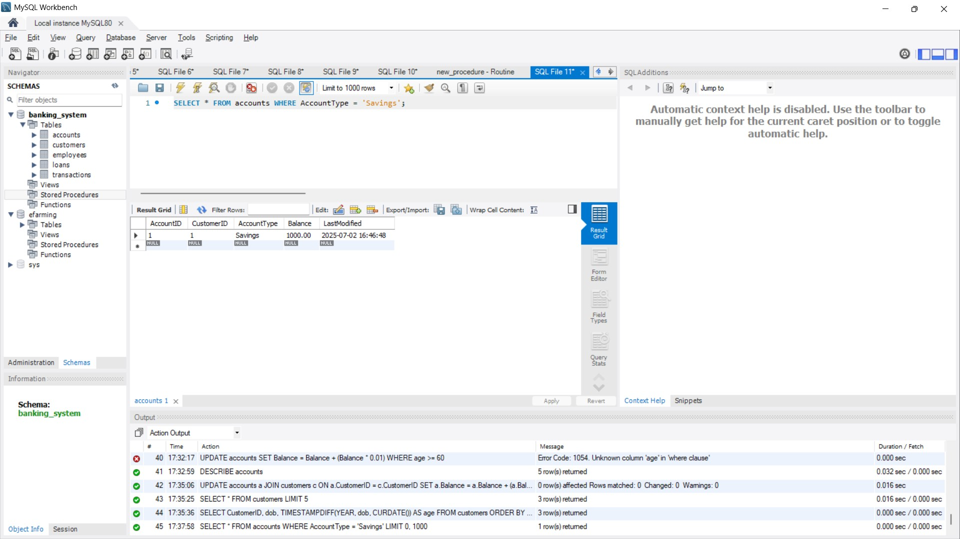

**Scenario 2:** The bank wants to implement a bonus scheme for employees based on their performance. **Question:** Write a stored procedure **UpdateEmployeeBonus** that updates the salary of employees in a given department by adding a bonus percentage passed as a parameter.

**ANS**

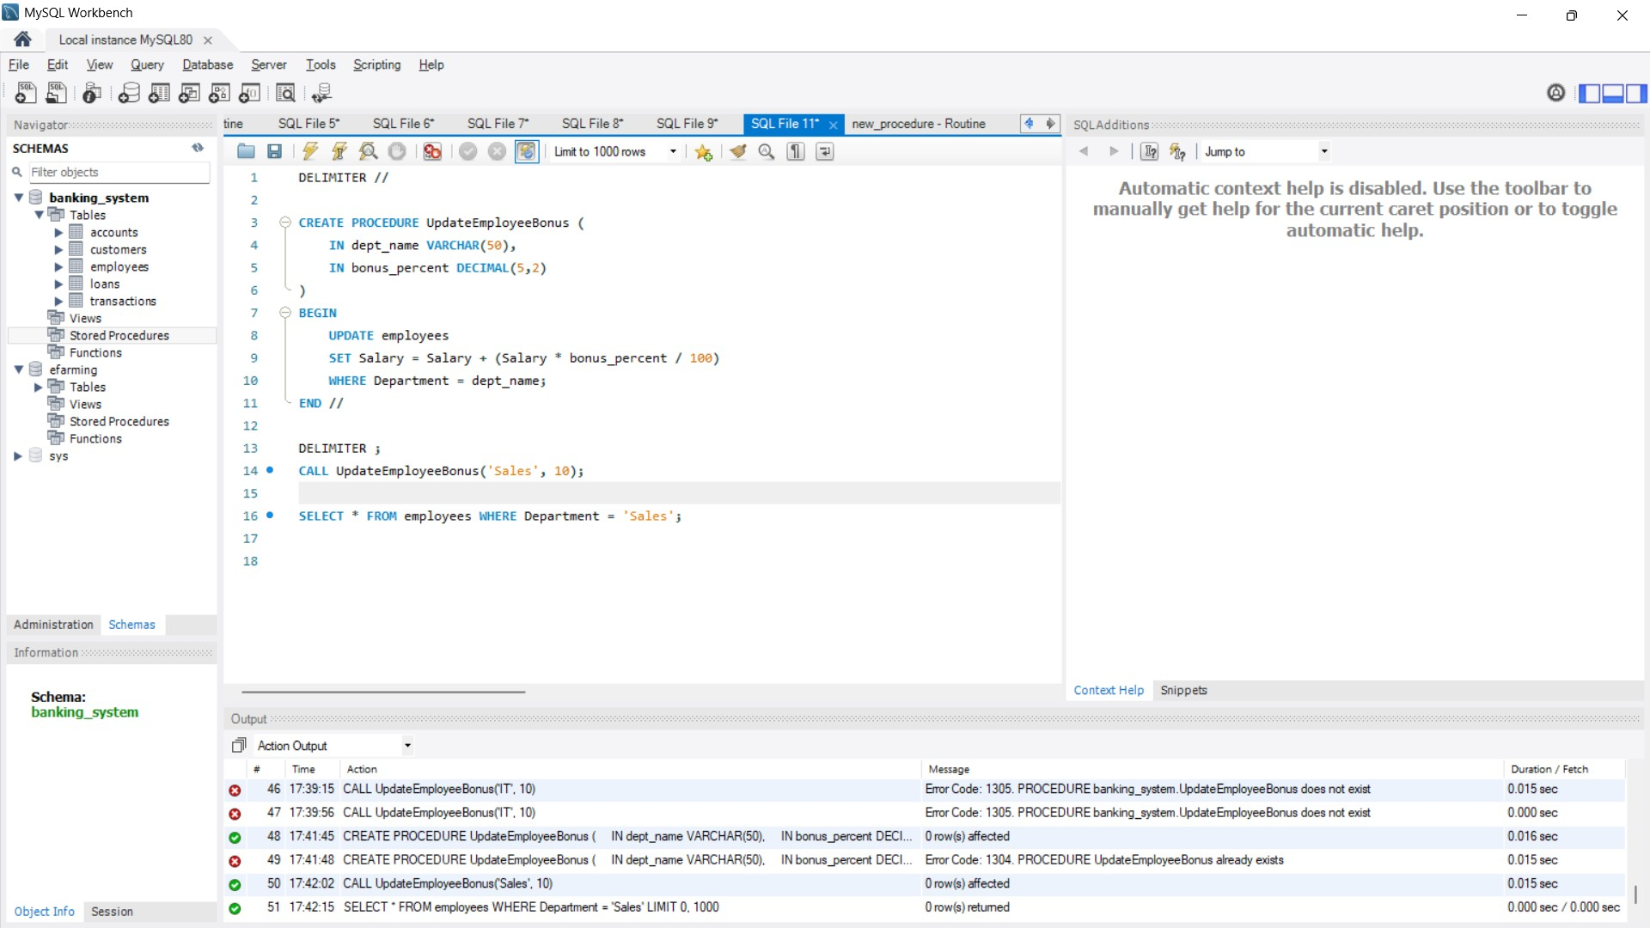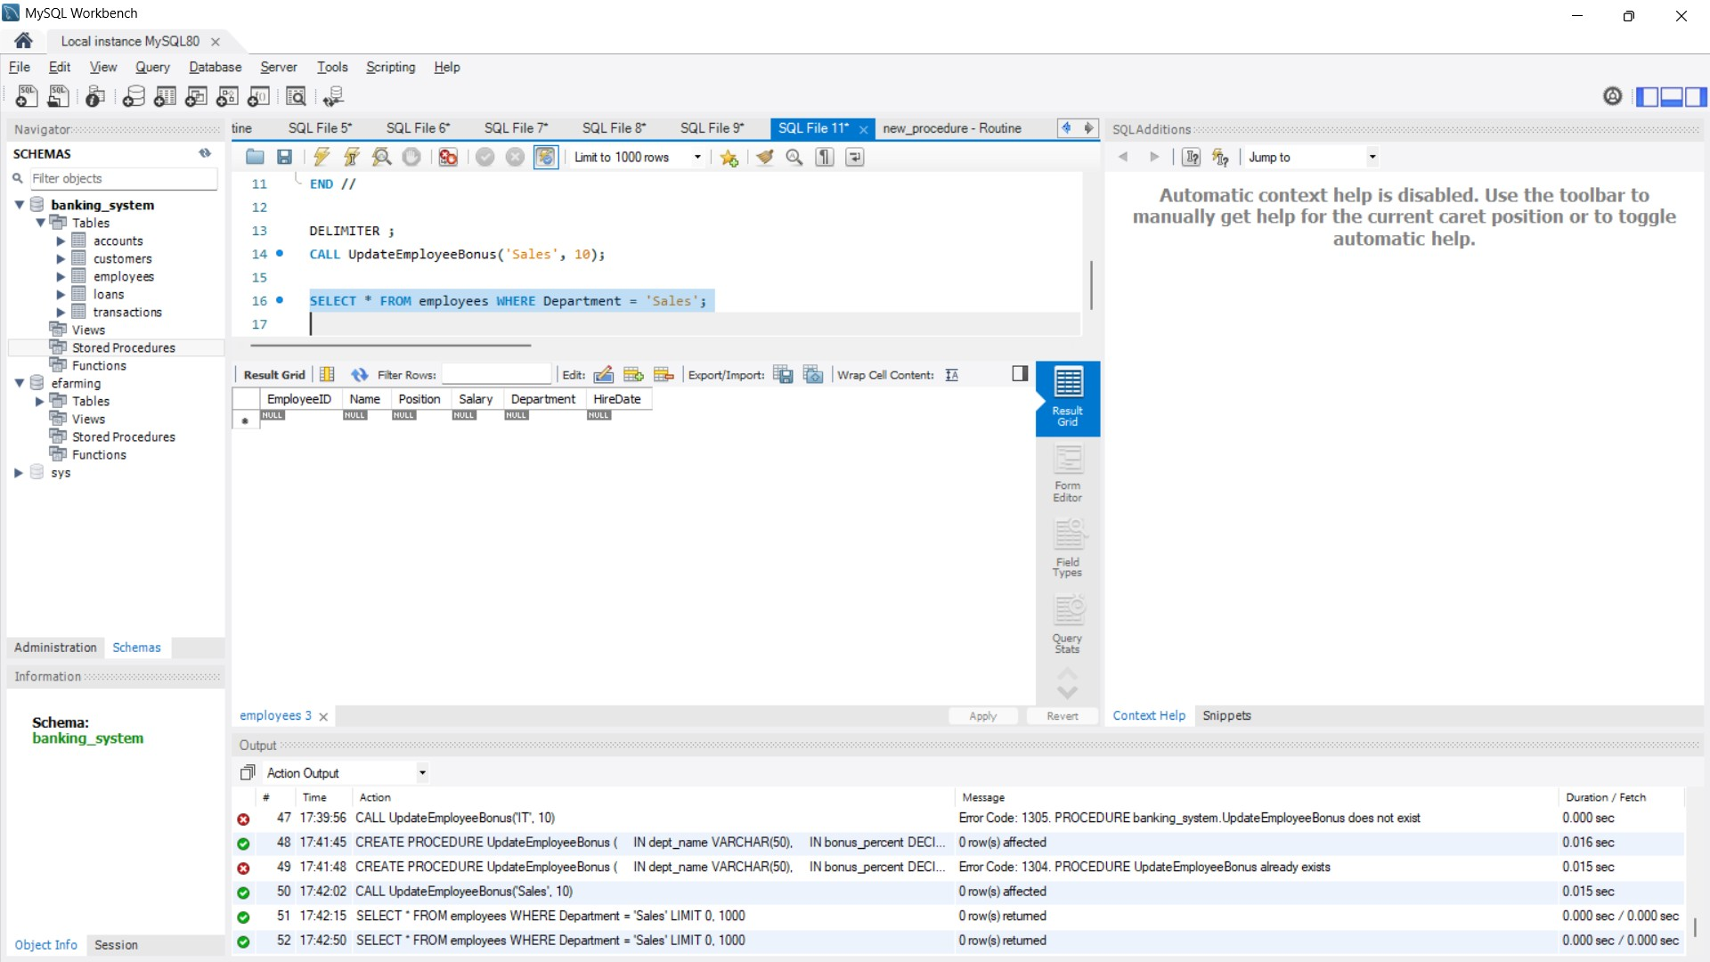

**Scenario 3:** Customers should be able to transfer funds between their accounts.

**Question:** Write a stored procedure **TransferFunds** that transfers a specified amount from one account to another, checking that the source account has sufficient balance before making the transfer. **ANS**

